PYTHON PRACTICAL RECORD
Program Names • Algorithms • Symbol-Based Flowcharts • Pseudocode • Test Cases • Output Screenshots
Standard symbols: Oval = Start/End; Parallelogram = Input/Output; Rectangle = Process; Diamond = Decision. Arrows show the direction of the program flow.
Prepared in simple English from the provided program screenshots. Each program includes a standard-symbol flowchart and its output screenshot.

Contents
- 1. Shopping Bill Calculator
- 2. Retail Billing System
- 3. Exam Result Calculator
- 4. Attendance Recovery Calculator
- 5. ATM Transaction Menu
- 6. Performance Trend Analyzer
- 7. Shopping Budget Checker
- 8. Numeric Pattern Generator
- 9. Text Compression (Run-Length Encoding)

1. Shopping Bill Calculator
Aim: To calculate the total cost of three items using their prices and quantities.

Algorithm
- Start the program.
- Set total = 0.
- Enter the price and quantity for each of 3 items.
- If price or quantity is negative, display an error and stop.
- Add price × quantity to total for each item.
- Display the total bill and stop.

Python Program
total = 0.0
for item in range(1, 4):
price = float(input(f"Enter price of item {item}: ₹"))
quantity = int(input(f"Enter quantity of item {item}: "))
if price < 0 or quantity < 0:
print("Error: price and quantity cannot be negative.")
raise SystemExit
total += price * quantity
print(f"Total shopping bill: ₹{total:.2f}")

Flowchart with Standard Symbols
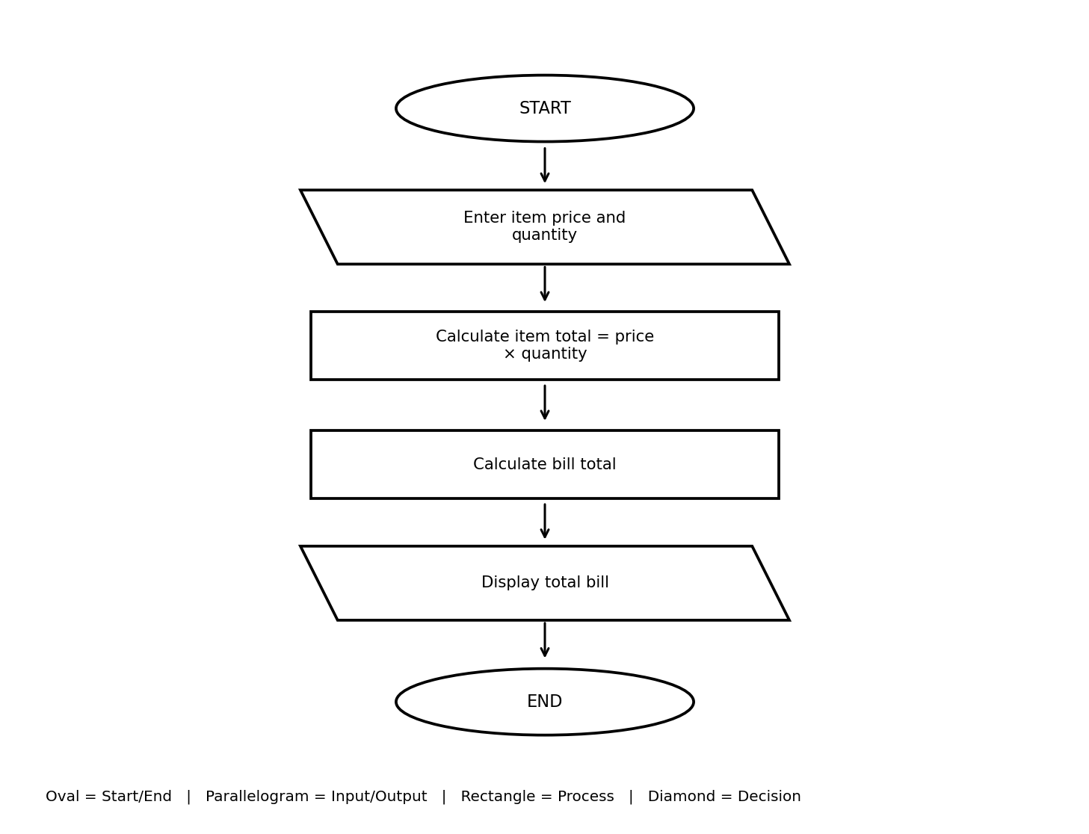

Pseudocode
START
total = 0
REPEAT 3 TIMES:
INPUT price, quantity
IF price < 0 OR quantity < 0, SHOW error and STOP
total = total + price * quantity
DISPLAY total bill
STOP

Test Cases
Test | Input | Expected result
Valid values | Enter prices and quantities for 3 items | Total bill is displayed
Negative value | Enter a negative price or quantity | Error message appears

Output Screenshot
The screenshot shows the total shopping bill as ₹55.00.
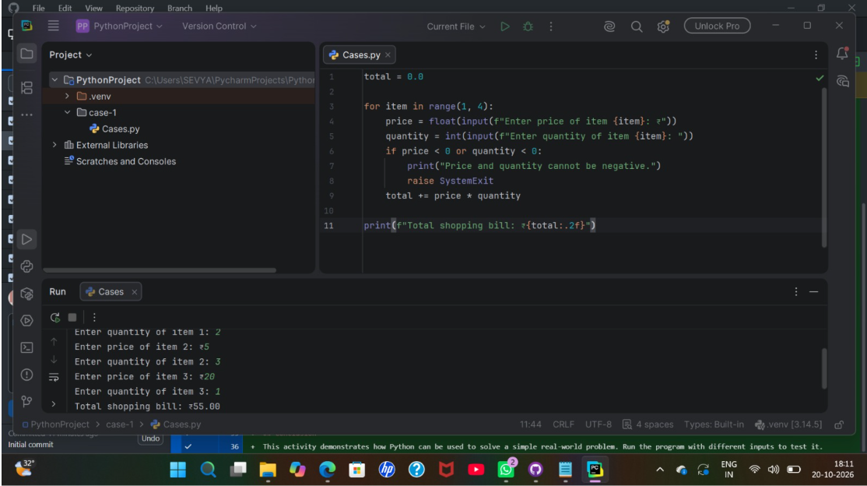

2. Retail Billing System
Aim: To prepare a bill for items and calculate the grand total.

Algorithm
- Enter the number of items.
- Set grand_total = 0.
- For each item, enter its name, quantity and price.
- Calculate subtotal = quantity × price.
- Add subtotal to grand_total and display the item details.
- Display grand_total and stop.

Python Program
n = int(input("Enter number of items: "))
if n <= 0:
print("Error: number of items must be positive.")
raise SystemExit
grand_total = 0.0
for i in range(1, n + 1):
name = input(f"Enter name of item {i}: ")
quantity = int(input("Enter quantity: "))
price = float(input("Enter unit price: ₹"))
if quantity < 0 or price < 0:
print("Error: quantity and price cannot be negative.")
raise SystemExit
subtotal = quantity * price
grand_total += subtotal
print(f"{name}: {quantity} x ₹{price:.2f} = ₹{subtotal:.2f}")
print(f"Grand Total: ₹{grand_total:.2f}")

Flowchart with Standard Symbols
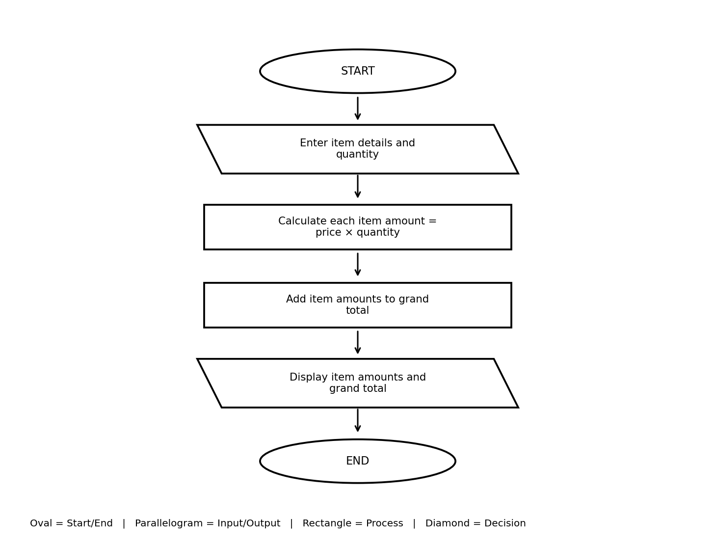

Pseudocode
START
INPUT number of items
grand_total = 0
FOR each item:
INPUT name, quantity, price
subtotal = quantity * price
grand_total = grand_total + subtotal
DISPLAY item and subtotal
DISPLAY grand_total
STOP

Test Cases
Test | Input | Expected result
One book | Book, quantity 1, price ₹50 | Book subtotal = ₹50.00
Several items | Enter two or more items | Each subtotal and grand total are displayed

Output Screenshot
The visible output includes Book: 1 × ₹50.00 = ₹50.00 and Grand Total: ₹70.00.
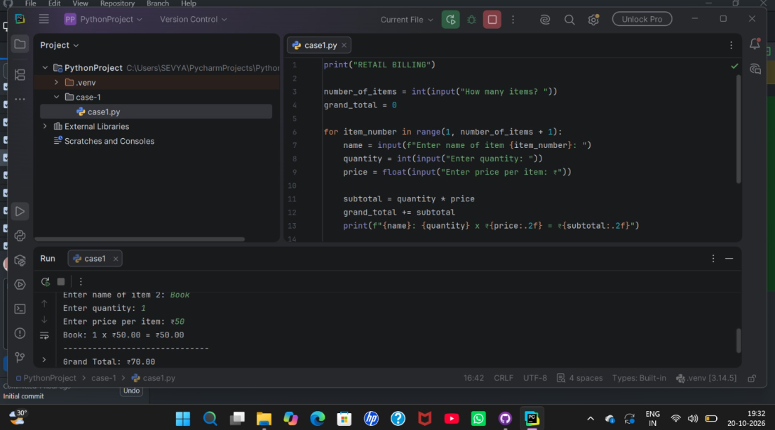

3. Exam Result Calculator
Aim: To calculate average marks, assign a grade and decide whether the student passes.

Algorithm
- Enter the number of subjects.
- Set total = 0 and pass = YES.
- Enter marks for each subject.
- If marks are outside 0–100, display an error and stop.
- Add marks to total. If any mark is below 35, set pass = NO.
- Calculate average, find the grade and display the result.

Python Program
n = int(input("Enter number of subjects: "))
if n <= 0:
print("Error: enter at least one subject.")
raise SystemExit
total = 0
passed = True
for i in range(1, n + 1):
marks = float(input(f"Enter marks for subject {i} (0-100): "))
if marks < 0 or marks > 100:
print("Error: marks must be between 0 and 100.")
raise SystemExit
total += marks
if marks < 35:
passed = False
average = total / n
if average >= 90:
grade = "A"
elif average >= 75:
grade = "B"
elif average >= 60:
grade = "C"
elif average >= 35:
grade = "D"
else:
grade = "F"
print(f"Average: {average:.2f}")
print(f"Grade: {grade}")
print("Result: Pass" if passed else "Result: Fail")

Flowchart with Standard Symbols
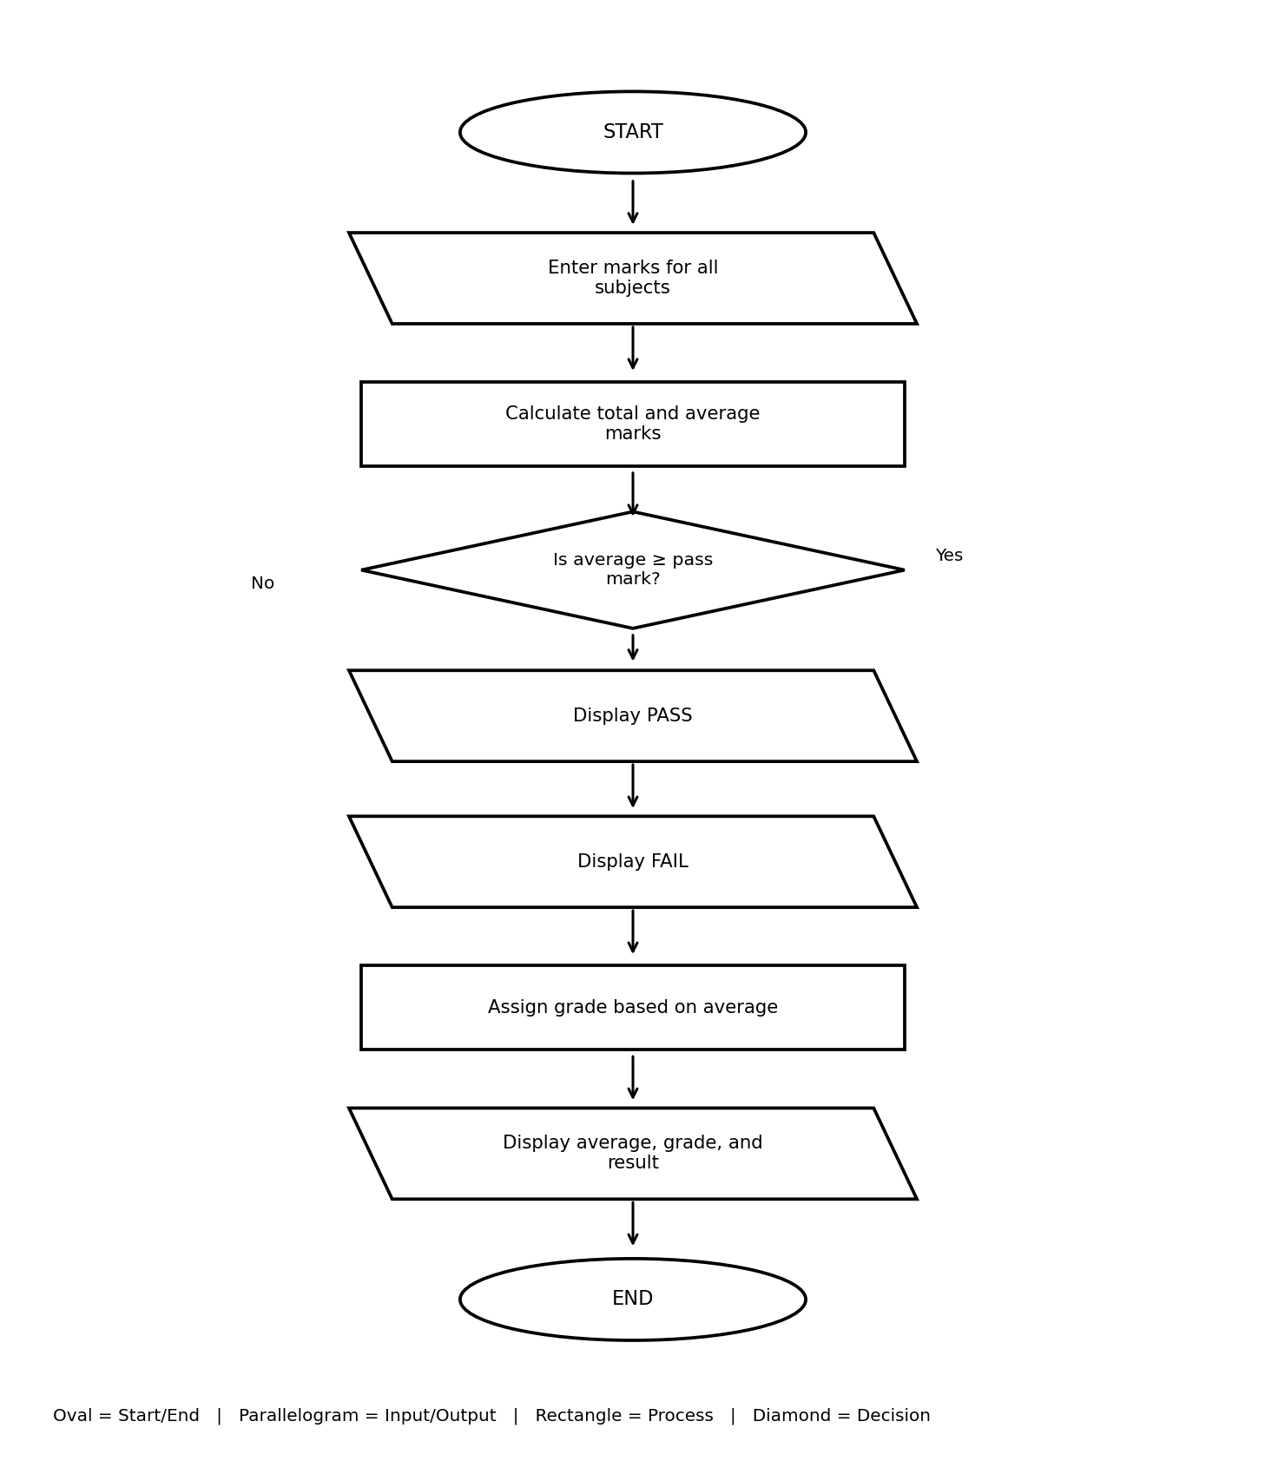

Pseudocode
START
INPUT number of subjects
total = 0; pass = YES
FOR each subject:
INPUT marks
IF marks < 0 OR marks > 100, SHOW error and STOP
total = total + marks
IF marks < 35, pass = NO
average = total / number of subjects
FIND grade
DISPLAY average, grade and result
STOP

Test Cases
Test | Input | Expected result
Passing marks | 90, 85, 95 | Average 90.00, Grade A, Pass
Low mark | One mark is below 35 | Result is Fail
Invalid mark | Enter 105 | Invalid marks message appears

Output Screenshot
The screenshot shows Average: 90.00, Grade: A, Result: Pass.
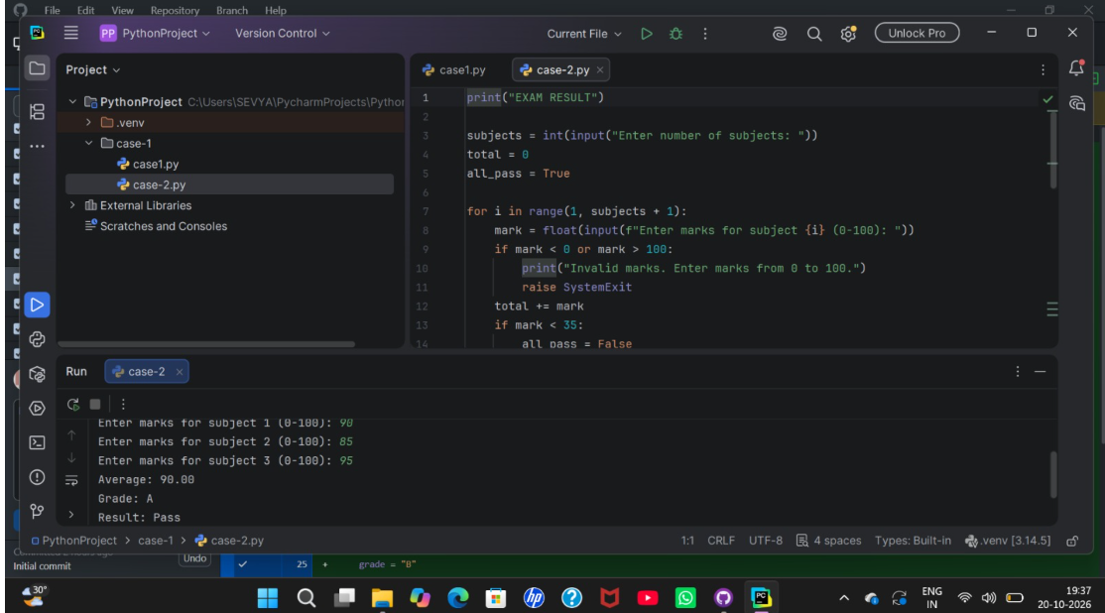

4. Attendance Recovery Calculator
Aim: To find how many extra classes are needed to reach the target attendance.

Algorithm
- Enter attended classes, total classes and target percentage.
- Check that all values are valid.
- Calculate current attendance percentage.
- Set extra = 0.
- While attendance is below target, add one attended class and one total class; increase extra by one.
- Display extra classes and final attendance.

Python Program
attended = int(input("Enter classes attended: "))
total = int(input("Enter total classes held: "))
target = float(input("Enter target attendance percentage: "))
if total <= 0 or attended < 0 or attended > total or not 0 <= target <= 100:
print("Error: enter valid attendance values.")
raise SystemExit
extra = 0
while attended / total * 100 < target:
attended += 1
total += 1
extra += 1
print(f"Extra classes needed: {extra}")
print(f"Final attendance: {attended}/{total} = {attended / total * 100:.2f}%")

Flowchart with Standard Symbols
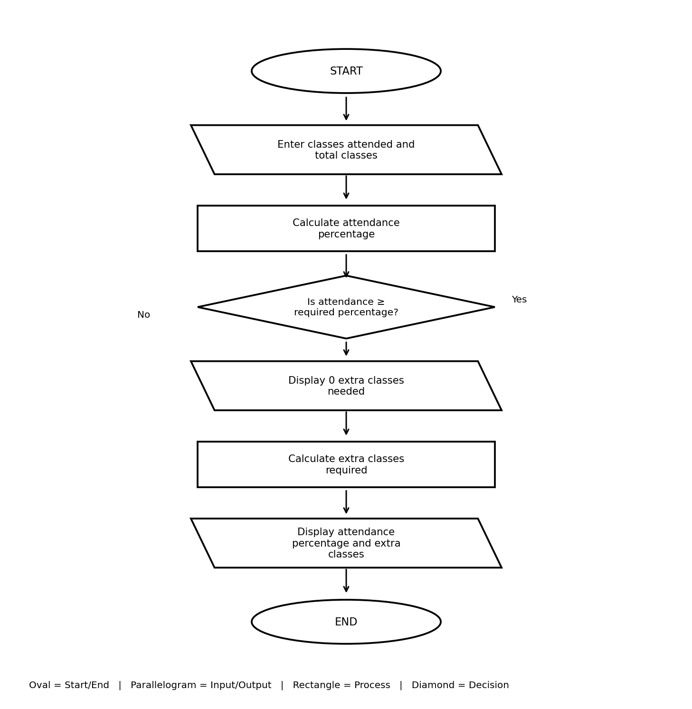

Pseudocode
START
INPUT attended, total, target
IF values are invalid, SHOW error and STOP
current = attended / total * 100
extra = 0
WHILE current < target:
attended = attended + 1
total = total + 1
extra = extra + 1
current = attended / total * 100
DISPLAY extra and final attendance
STOP

Test Cases
Test | Input | Expected result
At target | 18 attended, 24 total, target 75% | Extra classes = 0; attendance = 75%
Below target | Enter attendance below target | Extra classes counted until target is met
Invalid values | Total classes = 0 | Error message appears

Output Screenshot
The screenshot shows current attendance 18/24, 0 extra classes and 75.00% after recovery.
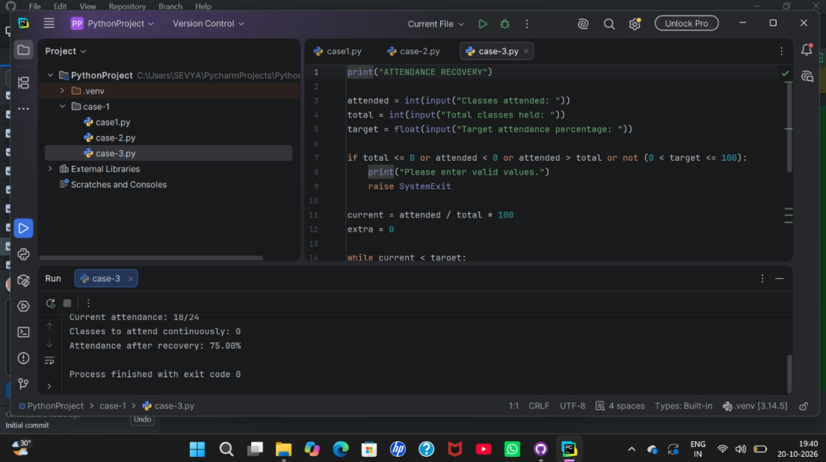

5. ATM Transaction Menu
Aim: To check balance, deposit money and withdraw money using a menu.

Algorithm
- Set balance = ₹5000.
- Display the menu and read the user's choice.
- If choice is 1, display balance.
- If choice is 2, add a positive deposit to balance.
- If choice is 3, withdraw only a valid amount within the balance.
- If choice is 4, exit; otherwise display an error and repeat the menu.

Python Program
balance = 5000.0
while True:
print("\n1. Check balance\n2. Deposit\n3. Withdraw\n4. Exit")
choice = input("Enter choice: ")
if choice == "1":
print(f"Available balance: ₹{balance:.2f}")
elif choice == "2":
amount = float(input("Enter deposit amount: ₹"))
if amount > 0:
balance += amount
print(f"New balance: ₹{balance:.2f}")
else:
print("Error: amount must be positive.")
elif choice == "3":
amount = float(input("Enter withdrawal amount: ₹"))
if amount <= 0:
print("Error: amount must be positive.")
elif amount > balance:
print("Error: insufficient balance.")
else:
balance -= amount
print(f"New balance: ₹{balance:.2f}")
elif choice == "4":
print("Thank you. Goodbye!")
break
else:
print("Invalid choice. Select 1, 2, 3 or 4.")

Flowchart with Standard Symbols
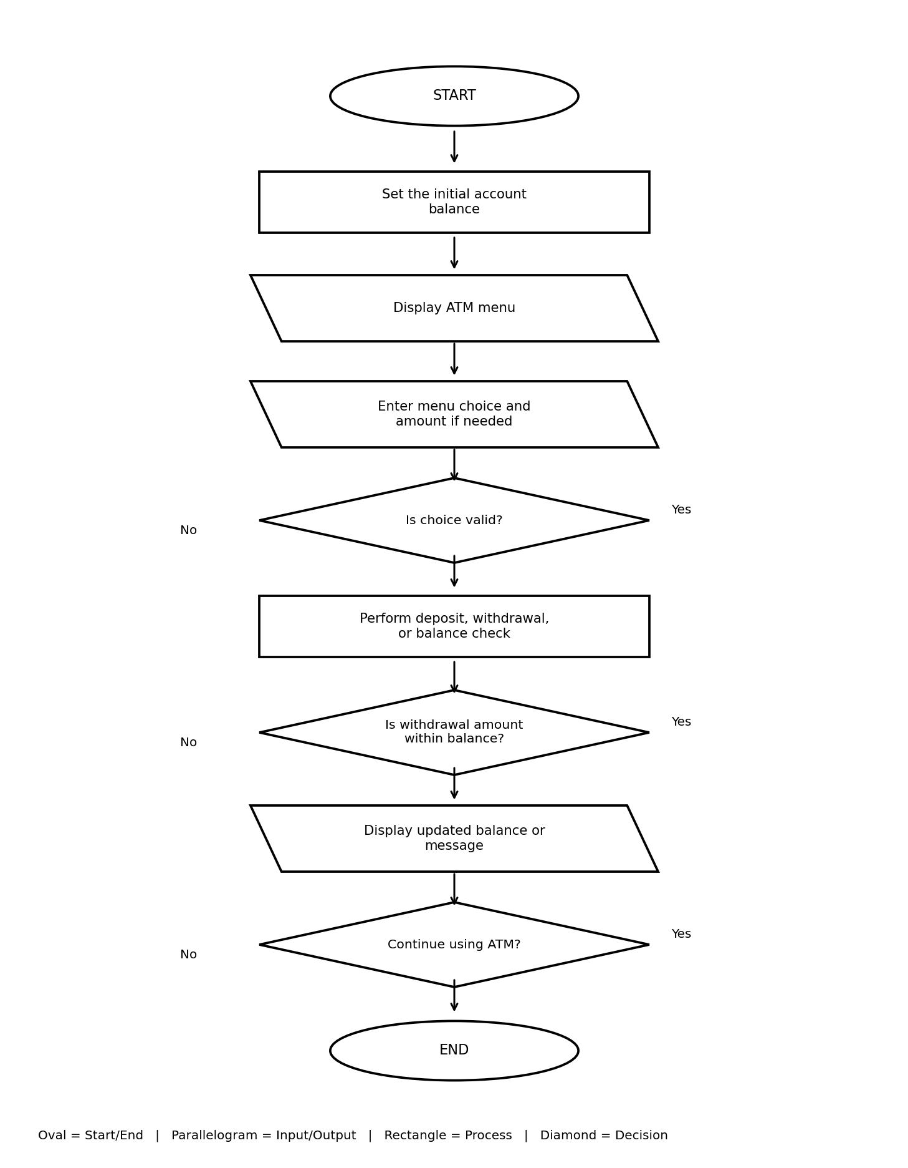

Pseudocode
START
balance = 5000
REPEAT:
DISPLAY menu: Balance, Deposit, Withdraw, Exit
INPUT choice
IF choice = 1, DISPLAY balance
IF choice = 2, INPUT amount and add if positive
IF choice = 3, INPUT amount and withdraw if valid
IF choice = 4, EXIT
UNTIL exit
STOP

Test Cases
Test | Input | Expected result
Check balance | Choose 1 | Balance ₹5000.00 is displayed
Deposit | Choose 2 and enter a positive amount | Balance increases
Withdraw | Choose 3 and enter a valid amount | Balance decreases
Exit | Choose 4 | Program ends

Output Screenshot
The screenshot shows Available balance: ₹5000.00.
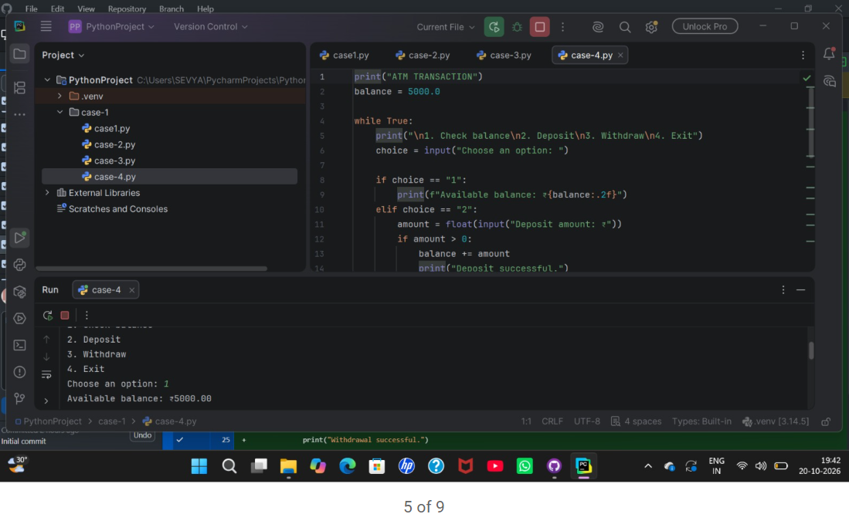

6. Performance Trend Analyzer
Aim: To calculate the average test marks and identify the performance trend.

Algorithm
- Enter the number of tests.
- If the number is zero or negative, display a message and stop.
- Enter and store the marks for each test.
- Calculate average = sum of marks ÷ number of tests.
- Compare marks to identify the trend.
- Display average and trend.

Python Program
n = int(input("Enter number of tests: "))
if n <= 0:
print("Please enter at least one test.")
raise SystemExit
marks = []
for i in range(1, n + 1):
marks.append(float(input(f"Enter marks for test {i}: ")))
average = sum(marks) / n
if len(marks) < 2:
trend = "Not enough tests to determine trend"
elif all(marks[i] > marks[i - 1] for i in range(1, n)):
trend = "Improving"
elif all(marks[i] < marks[i - 1] for i in range(1, n)):
trend = "Declining"
else:
trend = "Mixed or unchanged"
print(f"Average: {average:.2f}")
print(f"Trend: {trend}")

Flowchart with Standard Symbols
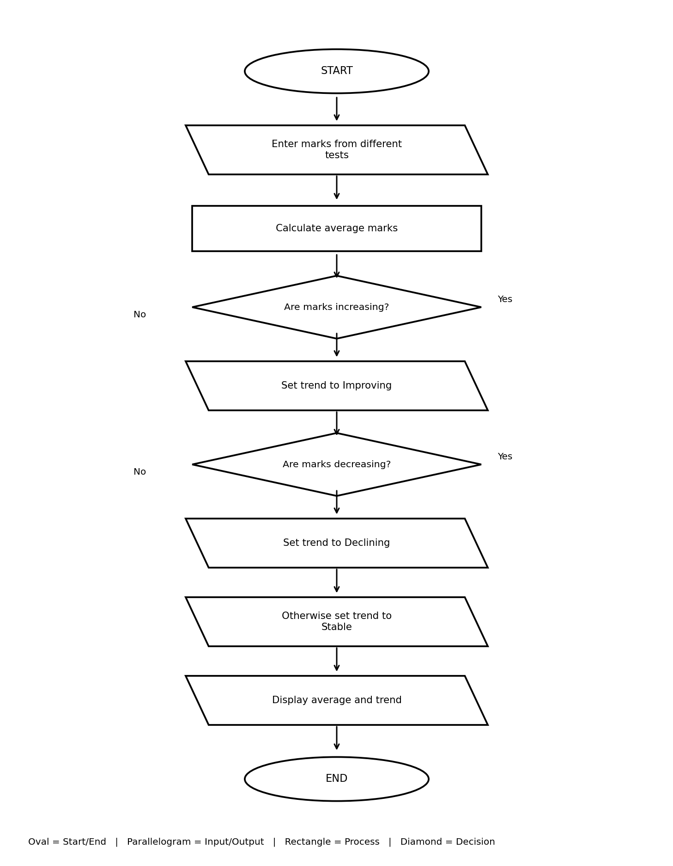

Pseudocode
START
INPUT number of tests
IF number <= 0, SHOW error and STOP
INPUT marks for each test
average = sum of marks / number of tests
CHECK marks to find trend
DISPLAY average and trend
STOP

Test Cases
Test | Input | Expected result
Improving marks | 50, 60, 75 | Average 61.67; trend Improving
No tests | Enter 0 | Message asks for at least one test

Output Screenshot
The screenshot shows marks 50, 60 and 75, average 61.67 and trend Improving.
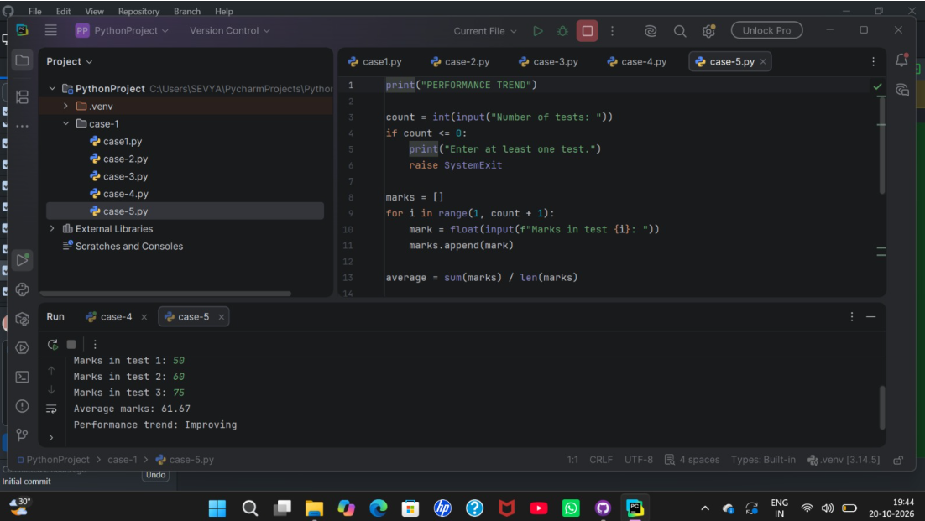

7. Shopping Budget Checker
Aim: To calculate total item cost and check whether it is within the budget.

Algorithm
- Enter budget and number of items.
- Set total = 0.
- Enter each item cost and add it to total.
- If a cost is negative, display an error and stop.
- Display total.
- If total is within budget, display money left; otherwise display the amount over budget.

Python Program
budget = float(input("Enter budget: ₹"))
n = int(input("Enter number of items: "))
if budget < 0 or n <= 0:
print("Error: budget must be non-negative and item count positive.")
raise SystemExit
total = 0.0
for i in range(1, n + 1):
cost = float(input(f"Enter cost of item {i}: ₹"))
if cost < 0:
print("Error: item cost cannot be negative.")
raise SystemExit
total += cost
print(f"Total cost: ₹{total:.2f}")
if total <= budget:
print(f"Money left: ₹{budget - total:.2f}")
else:
print(f"Amount over budget: ₹{total - budget:.2f}")

Flowchart with Standard Symbols
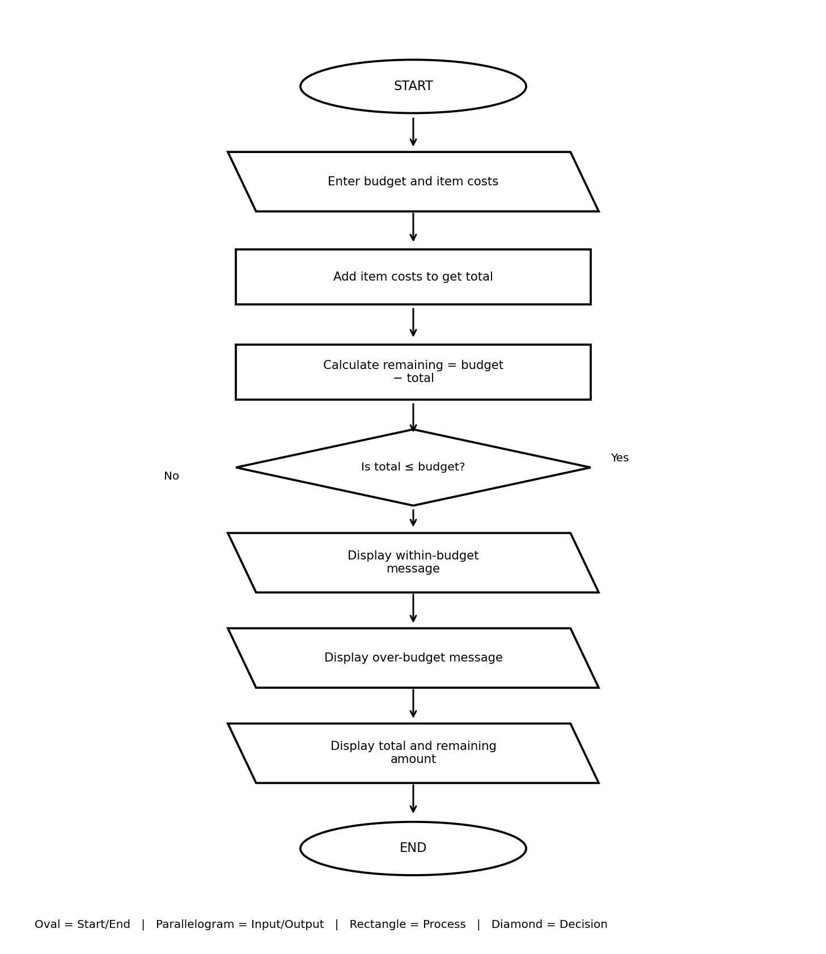

Pseudocode
START
INPUT budget and number of items
total = 0
FOR each item:
INPUT cost
IF cost < 0, SHOW error and STOP
total = total + cost
DISPLAY total
IF total <= budget, DISPLAY money left
ELSE DISPLAY amount over budget
STOP

Test Cases
Test | Input | Expected result
Within budget | Budget ₹1000; costs ₹200 and ₹300 | Total ₹500; money left ₹500
Over budget | Costs exceed budget | Amount over budget is displayed
Negative cost | Enter a cost below zero | Error message appears

Output Screenshot
The screenshot shows a ₹1000 budget, item costs ₹200 and ₹300, total ₹500.00 and ₹500.00 left.
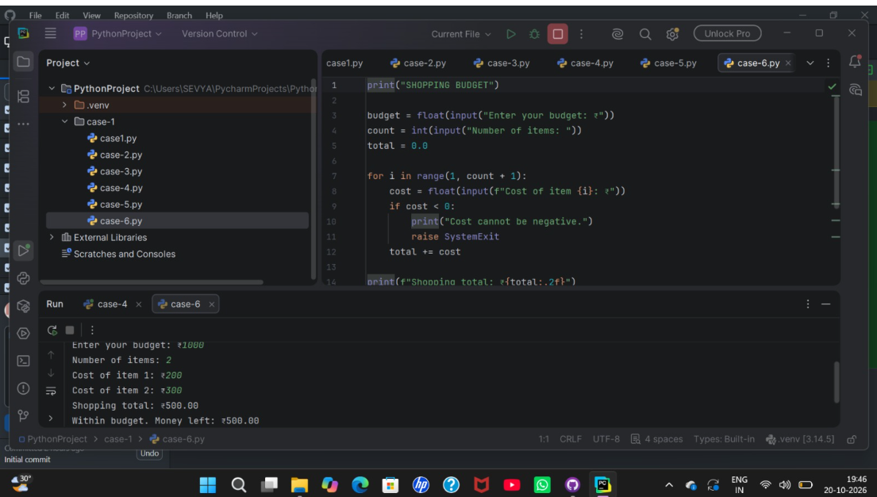

8. Numeric Pattern Generator
Aim: To print rows of numbers from 1 up to the row number.

Algorithm
- Enter the number of rows.
- If rows is zero or negative, display an error and stop.
- For each row from 1 to rows, print numbers from 1 to the row number.
- Move to a new line after each row.
- Stop.

Python Program
rows = int(input("Enter number of rows: "))
if rows <= 0:
print("Please enter a positive number of rows.")
raise SystemExit
for row in range(1, rows + 1):
for number in range(1, row + 1):
print(number, end="")
print()

Flowchart with Standard Symbols
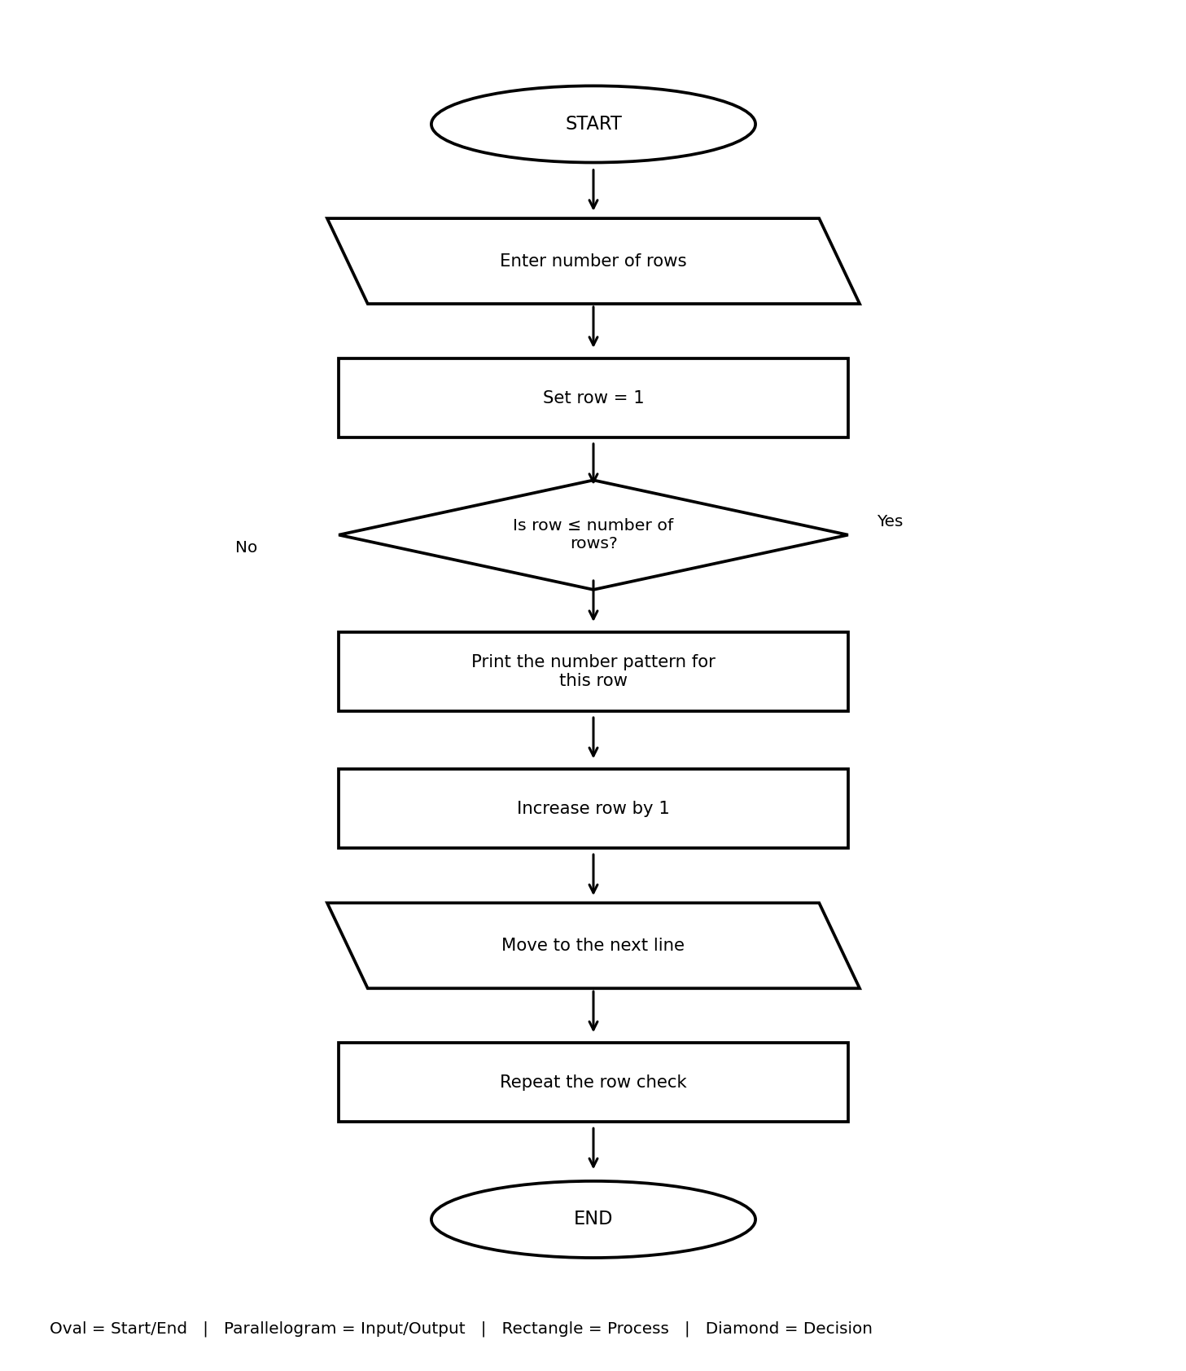

Pseudocode
START
INPUT rows
IF rows <= 0, SHOW error and STOP
FOR row = 1 TO rows:
FOR number = 1 TO row:
DISPLAY number on same line
MOVE to next line
STOP

Test Cases
Test | Input | Expected result
Four rows | Enter 4 | 1 / 1 2 / 1 2 3 / 1 2 3 4
Zero rows | Enter 0 | Positive-number message appears

Output Screenshot
The screenshot shows the Numeric Pattern program with 4 rows; part of the output is visible.
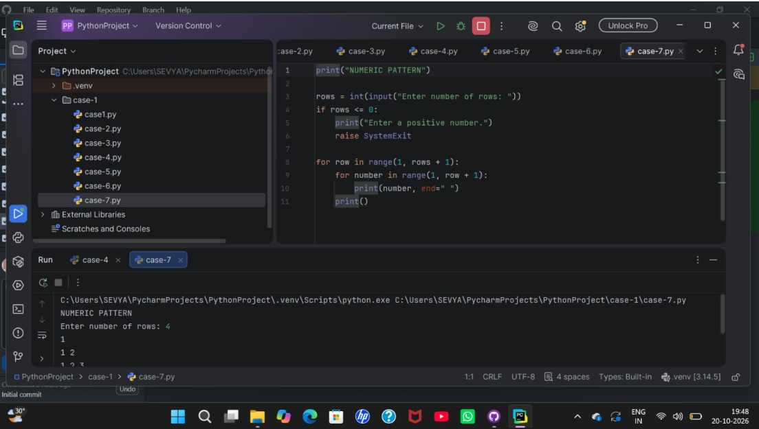

9. Text Compression (Run-Length Encoding)
Aim: To shorten repeated characters by writing each character followed by its count.

Algorithm
- Enter a text string.
- If text is empty, display a message and stop.
- Set current character to the first character and count = 1.
- Read the next character. If it matches current, increase count.
- If it differs, save current character and count, then start counting the new character.
- Save the last character and count; display compressed text and stop.

Python Program
text = input("Enter text: ")
if text == "":
print("Error: text cannot be empty.")
raise SystemExit
compressed = ""
current = text[0]
count = 1
for char in text[1:]:
if char == current:
count += 1
else:
compressed += current + str(count)
current = char
count = 1
compressed += current + str(count)
print(f"Compressed text: {compressed}")

Flowchart with Standard Symbols
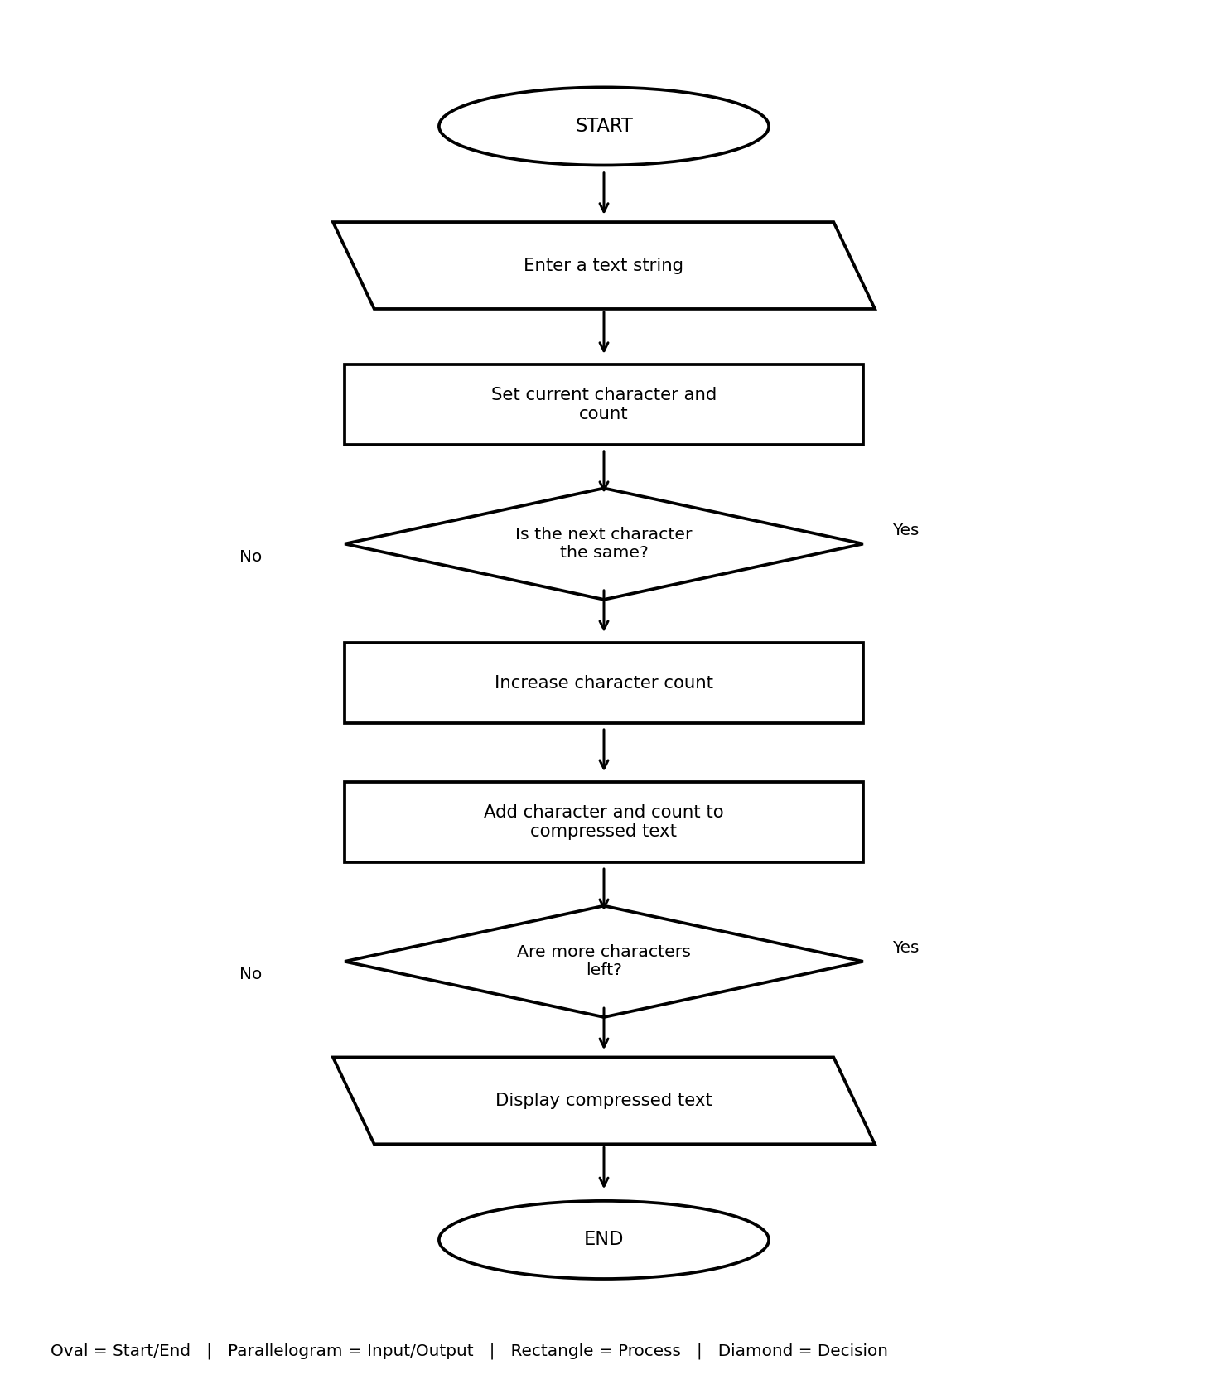

Pseudocode
START
INPUT text
IF text is empty, SHOW error and STOP
SET current = first character; count = 1
FOR each next character:
IF character = current, count = count + 1
ELSE save current and count; set new current and count = 1
SAVE final character and count
DISPLAY compressed text
STOP

Test Cases
Test | Input | Expected result
Repeated characters | aaabbc | Compressed text: a3b2c1
No repeats | abcd | Compressed text: a1b1c1d1
Empty text | Press Enter without text | Empty-input message appears

Output Screenshot
The screenshot shows input aaabbc and output a3b2c1. The last screenshot in the original set is another view of this program.
